Github vs Jira tools
In the Github can be monitor entire project work resources performance like jira tool and difference between github and jira
Explanation:
- Github:
- Github can tasks like code, issues, pull requests and basic project tracking
- Github project tracking and code management and developer collaboration
Diagram:
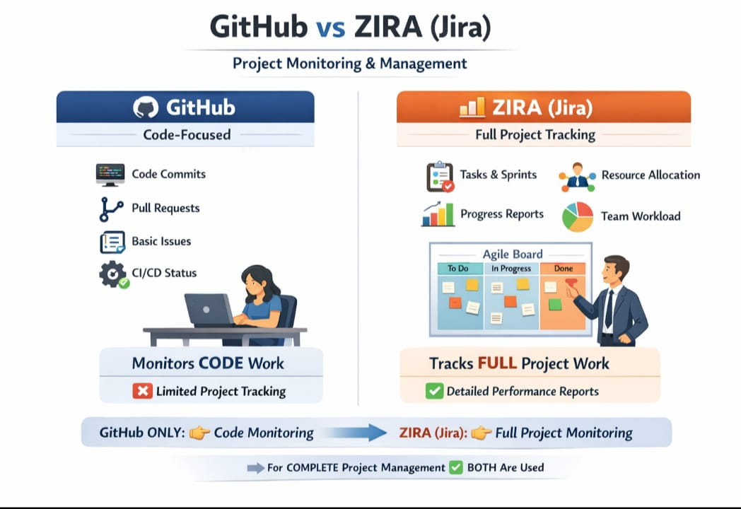
- Jira:
- Jira is much stronger for full project monitoring task tracking and team performance
- Jira tool project tracking+ people performance monitoring
- Jira tool is not uploading on working files
- Github/Jira tool table:
